
CAMPUS EMPLOYMENT
Office of Career and Student Development | Student Center
700 University Avenue, Monroe, LA 71209 | Phone: (318) 342‐5338 Email: campusjobs@ulm.edu|URL: ulm.edu/careerdevelopment/campus-employment

STUDENT WORKER PAY RATE INCREASE JUSTIFICATION FORM


Select One: 03 Worker 04 Worker

Student Name: CWID:

Student Job Title: Department:

Supervisor: Supervisor Phone#:

Supervisor Email: Pay Rate Requested:
Listed below are the justifiable reasons for a pay rate increase for a student employee. Pay rate increases are neither retroactive nor automatic.
For 04 Workers: Please attach this form to any student's Work‐Study Authorization Form if they are to be paid more than the pay assigned to this position. A pay rate increase can ONLY be granted by the Student Employment Coordinator. Do not promise any student a pay rate increase until you have the approval for the increase from the Student Employment Coordinator. If you are completing this form after a student has already been approved as an 04 worker, it does not have to accompany a Work‐Study Authorization Form.

Check the reason for increase in pay rate:
Superior job performance: You should attach justification to this form that cites the student's work habits, abilities, character, and other outstanding qualities which merit an increase in pay. You can also include any performance evaluations that were completed. Generally, a student should not be considered for a pay rate increase until the student has been working in a department for at least one semester.
Longevity: Pay rate increases may be requested for students who have worked for the same department at the same pay rate for two consecutive semesters (Note: The maximum increase per consecutive term is $0.25 per hour. Any requests above this amount will be reduced.)
Type of work being performed: An increase may be granted if you believe the nature of the position this student employee will be performing is above the pay assigned to this position. Attach documentation to this form that justifies the pay increase (e.g. detailed job description, pay rates of other non‐04 workers doing the same job, etc.).

SUPERVISOR SIGNATURE: Date:

BUDGET HEAD SIGNATURE: Date:
(Required for 03 Workers only)

Submit this form to: 03 Workers – Human Resources, Coenen Hall 107
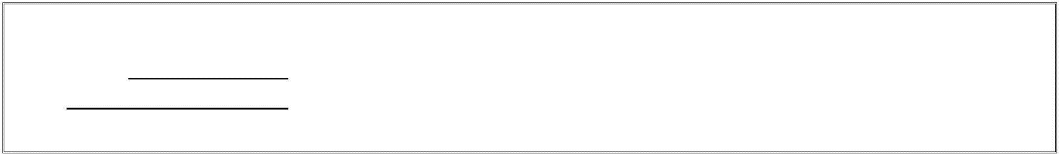


04 Workers – Career Development , Student Center 162A
Approved
Processed By:
Denied Additional notes:
OFFICE USE ONLY
Date:

